New Taipei City Yingge Ceramics Museum Application Exhibition

- Purpose：To encourage the variety of ceramic creations and elevate the standard of ceramic industry design, the New Taipei City Yingge Ceramics Museum is welcoming exhibition propositions to be displayed. Any individual or group of creators is welcomed to submit their application for an exhibition so that the Yingge Ceramics Museum becomes a platform to share the works with others.

- Event organizer：New Taipei City Yingge Ceramics Museum (hereinafter “the Museum”)

- Entry criteria：
- Any individual, group or curator interested in creating ceramic work.
- Participants who have not applied for a solo exhibition nor arranged to exhibit in the Museum within the last 2 years.
- The proposed entry should not be the result of a graduation exhibition or a class presentation of any institution, school or association.
- The participant is limited to submitting one application once within the year, and is not allowed to apply for other solo exhibition or participate in joint exhibitions in the Museum at the same time.

- Exhibition venue：The Sunlight Gallery on the first floor of the museum, the Ceramics Hallway on the first basement and the Citizen Ceramics Platform on the third floor. Please see attachments for site specifications and floor plan. The jury group will give suggestions on the most suitable places to present the pieces of works. The Yingge Ceramics Museum will decide the exhibition venue.

- Time of exhibition：
- All of the exhibitions will be held from the year of 2024 to 2025. Each theme of the exhibition will last about 4 weeks(does not include set-up and demounting time). The time needed to set up the site one to two days before the exhibition and to clean up afterwards should take one day each (the museum will be in charge of coordinating the time for each exhibition).
- The opening hours of the exhibition venue are in accordance with the regular Museum hours.
- The exhibition time is subject to major events held by the government authorities. The Museum will notify the candidates and coordinate any changes in the exhibition schedule.

- Exhibition guidelines：
- Theme of the works: No set theme and subject. The size of a single work can be no bigger than L2.2m xW1.7m x H2.0m. For installation works, size available depends on the exhibition ground. The works should be principally made with clay (clay must be more than 50% of the whole work).
- The proposed exhibition includes four categories: Creative, Functional, Curatorial and Industrial.
- Creative: Including applications for individual exhibition, double individual exhibition or group exhibition.
- Functional: Including applications for individual exhibition, double individual exhibition or group exhibition.
- Curatorial: Exhibition plan submitted by a curator or a group of curator.
- Industrial: Series of products created in recent two years by an individual studio, a ceramic design company or a ceramic factory. (Exhibited products should be self-made ones rather than all products from studios, companies or factories and OEM products.)

- How to apply：
- Documents to provide for application:
- Plan for exhibition (fill in table 1)
- Documents on the works to be shown (fill in table 2)
- Personal Data Consent Form (fill in table 3)
- Format of the pictures: The participants should prepare digital images of their works. The images should be in JPG format, clear, and true to the original work, 300dpi resolution, and 1-2 MB in file size. The definition should be 300dpi, 1-2MB and jpg format, please specify the artist, the title of the piece and its dimension.
- Solo exhibition:
- At least half of the works in the exhibition submitted for review must have been created within the last two years and never have been exhibited in other public or private galleries in Taiwan.
- Provide pictures of 10 to 20 pieces to be presented, do not exceed 20 pieces. Pictures from various angles of one piece are welcomed. Maximum 60 pictures for one application.
- Group exhibition:
- The works for review must not have been exhibited before in any public or private galleries in Taiwan.
- Each member in the group should submit at least one work for review. Maximum 60 pictures for one application.
- Application Period: Effective from 1st of July to 31st of July, 2022.
- Registration method:
- Submission by Email only, by the midnight 31st of July, 2022, Taiwan(GMT+8).
- Please download the application form from the website: http://www.ceramics. ntpc.gov.tw and mail it to ntpc60508@ntpc.gov.tw before the deadline. “Application for YCM Exhibition_Applicant” should be specified in the subject. Once you receive the confirmation letter, the registration is successful.

- Jury：
- Preliminary selection: The Museum will review applications in paper document format. The applicants will be notified to amend any missing information in their applications within the time limit. Entrants who are not complying with the notice will be disqualified.
- Secondary selection: The Yingge Ceramics Museum will be in charge of forming a group of jury that will include ceramics specialists, scholars and representatives from the museum. The group of jury of five persons will decide on which series of works to present.
- Results announcement: The list of applicants accepted to exhibit will be announced before 30th of September, 2022. It will be displayed on the Yingge Ceramics Museum’s website http://www.ceramics.ntpc.gov.tw . The chosen applicants will also be notified by e-mail.

- Members of the jury shall recuse themselves if they have any of the following relations with any of the entrants：
- Being a spouse or ex-spouse, a blood relatives within fourth degree of kinship, or an in-law within third degree of kinship of any of the entrants.
- Being a spouse or ex-spouse and joint obligee or joint obligor of any of the entrants.
- Being agent, assistant, or appraiser of any of the entrants.

- Rights on the exhibition：
- Principle: The pieces of work to be exhibited should correspond to the original applied project once that the applications have been approved by the jury members. If any pieces of works are to be replaced, no more than 40% are allowed for each entrant, and only 20% for group or curatorial projects. The Museum may conduct a separate review as necessary.
- Agreement: The approved applicants, either individuals or groups, can proceed to work on the exhibition area only after signing the exhibition agreement with the Yingge Ceramics Museum.
- Artworks submitted must not violate the Copyright Act and related laws through plagiarism, imitation, commissioning, forgery, or copyright infringement of other works or individuals. In the event of any such violation, the entrant will bear full legal liability and will be disqualified. The Museum reserves the right to pursue legal action against any violation that may damage the reputation of the Museum.
- Transportation and insurance:
- The transportation and insurance fee during the shipping of the pieces of work is at the expenses of the applicant. Please pack works securely. Applicants are fully responsible for any damage or loss during shipping. The Yingge Ceramics Museum will be in charge of the insurance during the exhibition. The highest insurance value of each exhibition session is NT$2,000,000. Higher amount of insurance value will be at the expenses of the applicant. All works are insured on the basis of restoration.
- The submitted art works will be examined for damages upon arrival. The Museum is only responsible for the safekeeping and insurance of intact works, counting from the date of receipt to the end of the exhibition. The Museum shall not be liable for any damages due to fragile materials, poor structure of the installation, experimental work, lack of unboxing instructions, nor any damages due to force majeure circumstances.
- Propaganda:
- The exhibiting ceramists should provide an article of 250 to 300 words in order to explain the theme of the exhibition, as well as instructions on the pieces (title, dimension, year of creation etc). The Yingge Ceramics Museum will be in charge of publishing press releases, introduction, illustration and other propaganda materials. The exhibition location may not post propaganda that are not produced by the Yingge Ceramics Museum.
- If any selected entrant advertises outside the museum, the content sample must be submitted to the museum for review before printing.
- Exhibition hall:
- The museum is equipped with various sizes of pedestals. The design of the site will be commonly decided by the exhibiting ceramist and the museum authorities. The exhibiting ceramist is responsible for additional platforms, setups and the additional cost. The exhibiting ceramist is requested to be on- site during the setting up and the cleaning up of the exhibition area to accomplish both tasks together.
- The selected entrants will plan the layout of the exhibition. However, the Museum reserves the right to make any adjustments to ensure the safety of the audience, the safety of the works, or any other safety issues in connection with the operation of the Museum.
- The selected entrants shall be held liable for any damages to the exhibition venue if they did not follow the Museum regulations. The Museum reserves the right to withdraw any exhibits if any security issues should occur during set up.
- Exhibits:
- To maintain the standard of the museum exhibitions, exhibits should be fired and be based on the principle of not easily broken and damaged. If exhibits are fragile, the Yingge Ceramics Museum has the right not to exhibit. After contacting exhibiting ceramist, the museum may re-arrange and adjust the number of the exhibits, exhibiting ceramist cannot object.
- The artwork is not available for sale during the exhibition period in the Museum. Price tags for the artworks or any other forms of commercial activities are prohibited during the exhibition. Any such violations will result in immediate withdrawal of the relevant entry works from the exhibition and a permanent ban of the entrant from future exhibition applications.
- Activities: If the exhibition involves an opening ceremony or tea party, please contact the Yingge Ceramics Museum for assistance. The exhibiting ceramist is responsible for the expense and need to give the guest list to the museum 7 days before the opening. Business activities and flower baskets or bouquets displayed at the exhibition venue are not allowed.

- Restrictions：
- In case that the applicant is not able of presenting his/her works on time or gives up the opportunity to exhibit the works in the Yingge Ceramics Museum, it should be submitted to the museum six months before the exhibition. The applicant is considered waiving his/her rights. If the applicant hasn’t gone through related application procedures causing the exhibition to delay, the applicant is also considered as waiving his/her rights of exhibiting the works and will be banned from applying for the museum’s exhibition for three years.
- In order to equally allocate the museum’s resources, the exhibiting ceramist will not be allowed to apply for an exhibition in the Yingge Ceramics Museum within two years.

- For any matters not covered herein, the Organizing Committee of the Museum reserves the right to amend, withdrawn, and/or supplement part or the entire project if necessary. Any modifications will be announced on the official website at any time.

- Contact us：
New Taipei City Yingge Ceramics Museum, Department of Collection and Exhibition
Address: No. 200, Wenhua Rd., Yingge Dist., New Taipei City 239218, Taiwan.
Telephone:+886-2-86772727,Fax: +886-2-86774034, Email: ntpc60508@ntpc.gov.tw
This application can be downloaded on the website of Yingge Ceramics Museum. (http://www.ceramics.ntpc.gov.tw)

- Attachment：Floor plan of the exhibition venue and a list of all the sizes of the display pedestals / platforms.

New Taipei City Yingge Ceramics Museum Exhibition Application Table 1
Qualification | □ Individual (for individual and double  individual)  □ Group |  |  | Category | □ Creation □ Functional  □ Curation □ Industry
Name of the applying group | □ Individual：  □ Group：  □ Curation：  □ Industry：
 | Name (In case of “double individual” and “group”, put only name of representative) |  |  | Gender | □ Female □ Male
 | Passport No.
Contact person | Name |  |  | Telephone(O)
 |  |  |  | Telephone(H)
 | E-mail |  |  | Cell phone
Address
Theme of the exhibition
Exhibition venue (Optional) |  | Exhibition design  (50 to 150 words)
□ 1F Sunlight Gallery
□ B1 Ceramics Hallway
□ 3F Citizen Ceramics Platform
Plan for Exhibition
(250 to 300 words)
※Photocopied version of this table is also accepted
※Data Protection Declaration: the above personal data is only processed or used within the scope necessary for this activity and limited to the relevant time period starting from the date of acquisition to the termination of data processed for the specific purpose. The data collection complies with the “Personal Data Protection Act” to prevent undue infringement of personal rights, and to facilitate the proper use of personal data.

New Taipei City Yingge Ceramics Museum Exhibition Application
List of pieces to be presented Table 2
Theme of the exhibition
Serial No. | Name of the artist | Title of the piece | Year of creation | a piece/  Set (quantity) | Dimension(cm)  Length×Width×Height | Materials and Techniques/Process temperature in degree ºC | Display method (stand, suspension, floor, wall, etc.)
1
2
3
4
5
6
7
8
9
10
◎Please number the pieces according to their order of presentation.
Signature of the creator: Photocopied version of this table is also accepted

Personal Data Protection Declaration
Table 3

According to Article 8 of the Personal Data Protection Act (hereinafter “the PDPA”), New Taipei City Yingge Ceramics Museum shall expressively inform the data subject about the following information. Please read it carefully.

- Purpose for gathering data: It is relevant to the data subject who participates in the application process of the “New Taipei City Yingge Ceramics Museum Application Exhibition” or makes inquiries or suggestions to the New Taipei City Yingge Ceramics Museum (hereinafter “the Museum”) by telephone, fax, email or other means of transmission.

- Types of data gathered: Any data collected through the relevant application form and contract with the Museum, or data generated during the period of official business dealings with the Museum, which belongs to the “personal data” as defined in Article 2 of the PDPA.

- Handling and uses of personal data:
    - The time period utilization: the period during which data is utilized, for the specific purpose of personal data collection, the retention period stipulated by the relevant laws or contracts for the preservation of data, or the retention period required by the Museum to perform official duties.
    - The region within which personal data is utilized: Taiwan (R.O.C.)
    - Recipient users and utilization of personal data:
      - New Taipei City Yingge Ceramics Museum
      - Any cooperating agency which may be investigated according to law
      - Inquiries or surveys by officials who have legitimate and reasonable cause to do so for the purpose of collecting data for the government agency
      - Based on goodwill that disclosure of personal data is necessary by law.
      - In case the data subject has violated the terms of the service of the official website and damaged the rights of the Museum or others, it is necessary for the Museum to take legal actions which will result disclosure of personal information.
      - Where it is for the rights and in the interests of the data subject.
      - Where consent has been given by the data subject.
      - Whoever is commissioned by the Museum to collect, process, or use personal
data, shall be deemed to be acting on behalf of the commissioning agency to the extent applied by the PDPA.
    - Methods of which the personal data is collected: the collection of personal data is structured to facilitate data retrieval and management by automated or non-automated means.

- According to the Article 3 of the PDPA, a data subject is entitled to make the following requests through written or oral notice to the Museum:
- To check, review, and to request a photocopy of the collected data. The Museum may charge necessary costs according to law.
- To supplement or revise the collected data on the account that the data subject give proper explanations. To cease the collection, processing, use or deletion of the collected data, unless it is deemed necessary to assist the Museum in performing its statutory duties.

- The data subject has the right to elect not to provide his/ her personal data. In this case, the Museum will not be able to carry out the necessary review and processing. This, however, will prevent the Museum from providing the data subject with related services.
□ I have carefully read the information provided by the New Taipei City Yingge Ceramics Museum in accordance with Article 8 of the PDPA and have a clear understanding of its purpose and the purpose of collecting, processing, and use of personal data.

Signature：

Date：

※Attachment：Floor plan of the exhibition venue

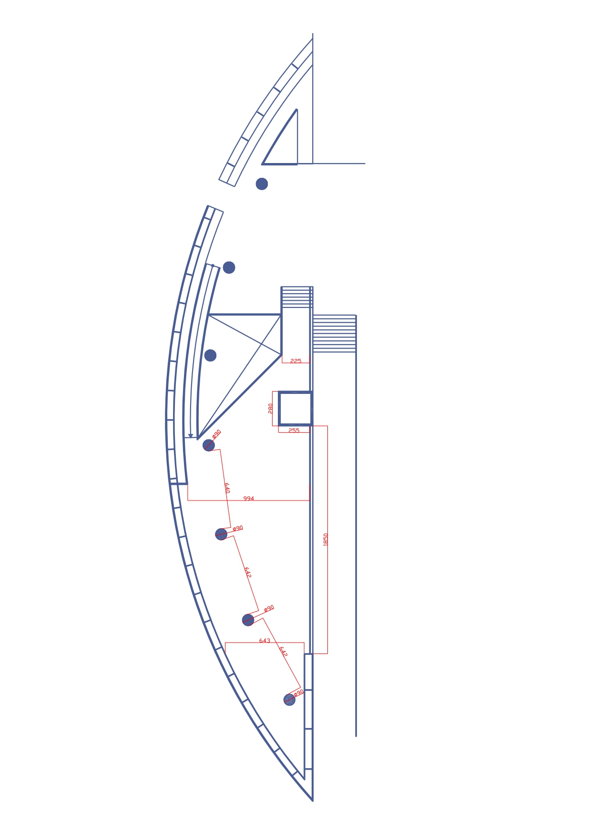
The Sunlight Gallery

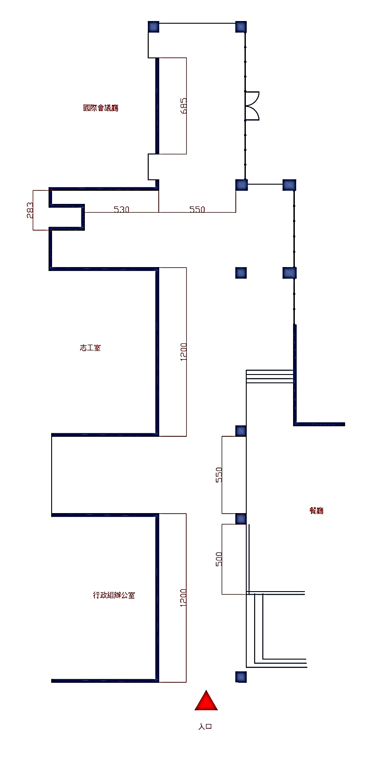
The Ceramics Hallway

Entrance
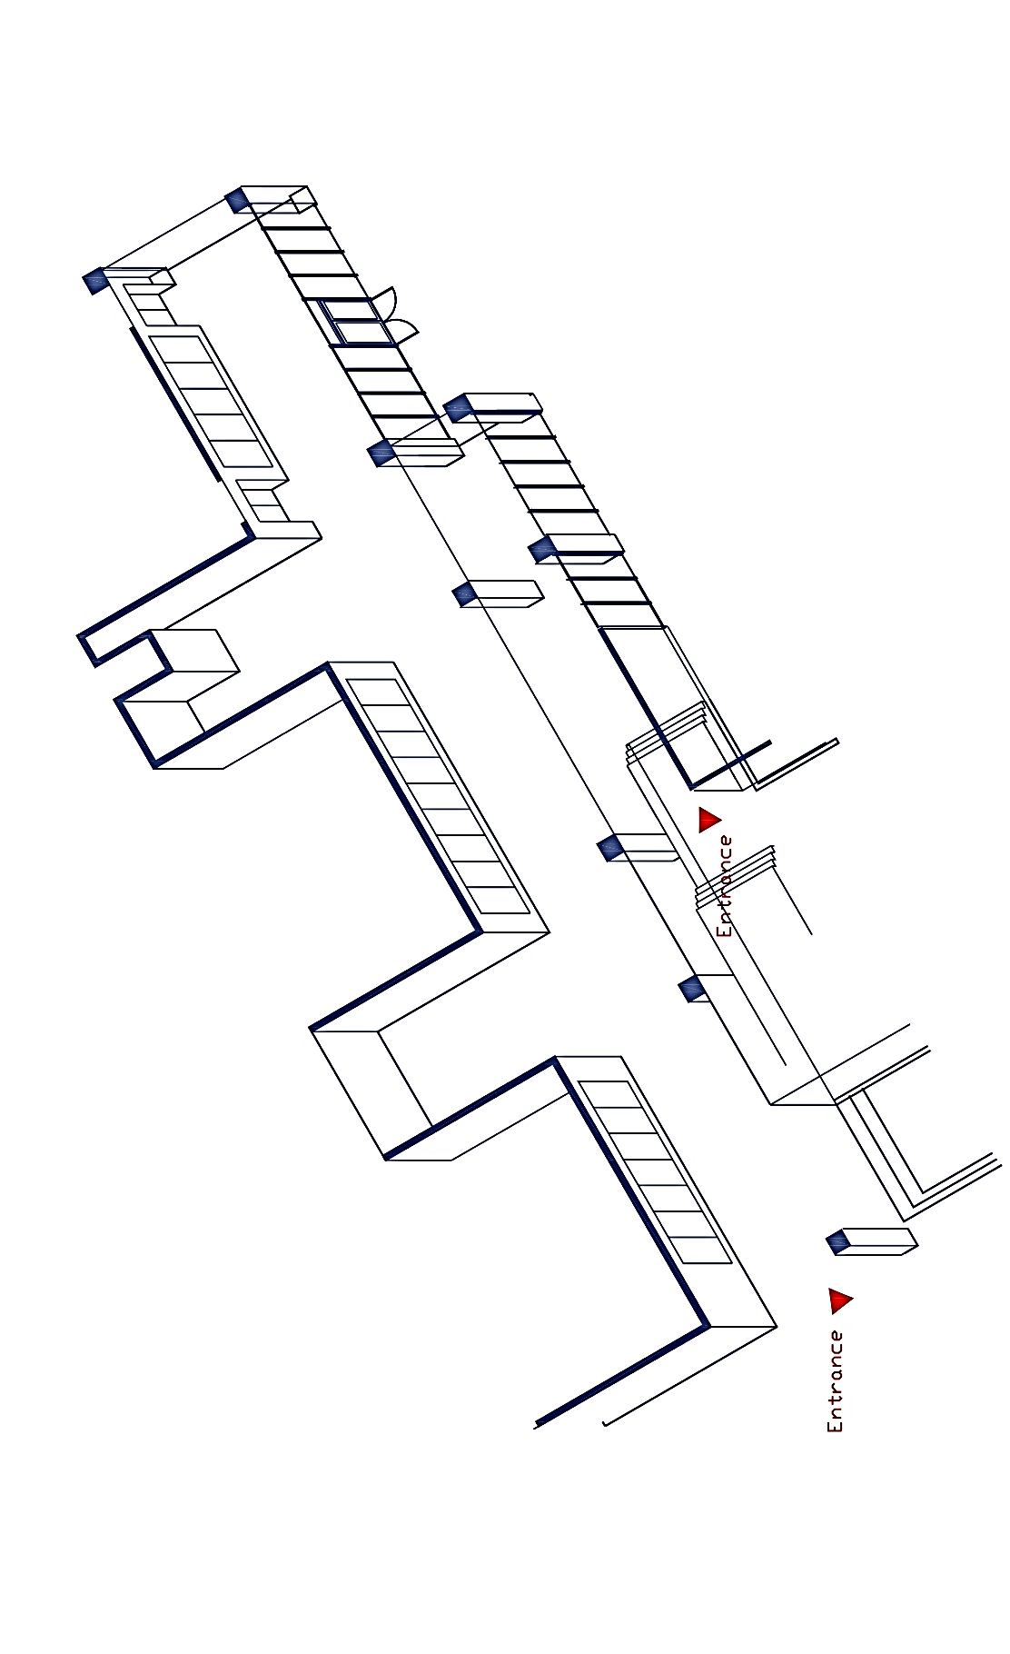

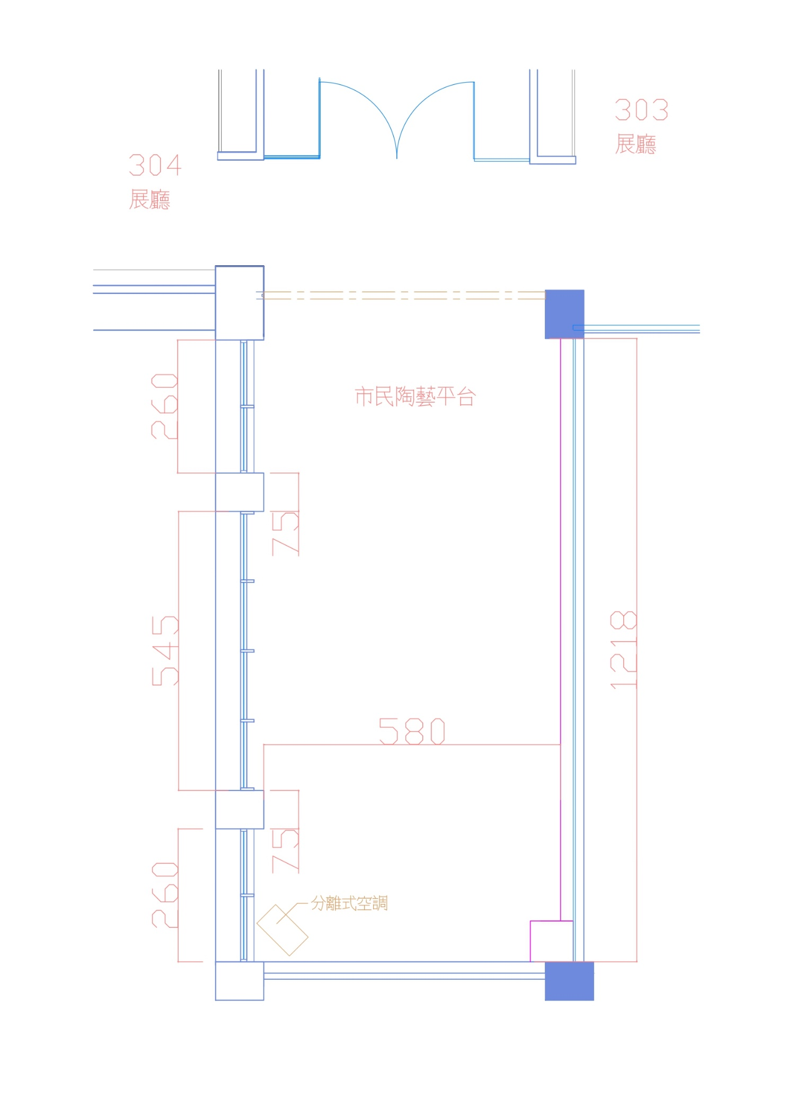

The Citizen Ceramics Platform

※Attachment：A list of all the sizes of the display pedestals / platforms (cm)

Display Cabinet A | L36×W36×H110 cm
Display Cabinet B | L48×W48×H100 cm
Display Cabinet C | L60×W60×H80 cm
Display Platform D | L75×W75×H60 cm
Display Platform E1 | L96×W96×H30 cm
Display Platform E2 | L96×W96×H60 cm
Display Platform F1 | L96×W150×H30 cm
Display Platform F2 | L96×W150×H60 cm
Display Platform G | L150×W150×H30 cm
Display Platform H | L210×W96×H30 cm
Display Platform I | L200×W60×H80 cm
Display Platform K | L320×W120×H8 cm

